SEZ Online Manual DTA Sale – Advance Duty Payment
Version 1.0

Table of Contents
1. Introduction 2
2. Preparation Of Advance Duty Deposit Request 3
3. Approval of Advance Duty Deposit Request by Customs 5
4. Search Advance Duty Deposit Request 6
5. Advance Duty Ledger Report 6
6. Utilization of Advance Duty Ledger balance for paying duty in DTA Sale Transaction 8
7. Various status of Advance Duty Deposit Request 9
8. Complete Workflow Of DTA Sale ADP Request. 10

Introduction
Certain SEZ units submit large volumes of DTA sale transactions on a daily basis. Instead of paying duty after assessment of each & every transaction through separate challan, through Advance duty register, the unit can pay advance duty to Customs. The duty amount payable gets subtracted from the advance duty register on each and every transaction submitted till the entire amount is utilized. On utilization of the entire advance duty amount, the SEZ Unit can again pay duty in advance.
A facility of maintenance of Advance Duty Register has been provided in SEZ Online System. Following are the advantages of having this facility:
- In the DTA Sale transaction, the workflow presently is as follows:
Unit (submission) Customs Assessor (Assessment) Unit (enters challan details) Authorized Officer (Verification of Challan details & issuance of out of Charge) Closure/End of transaction
In DTA Sale Requests where Advance Duty is paid by the unit, the request need not come back to the unit for entry of Challan details. Thus, eventually, the work flow of the transaction in SEZ Online System can be shorter as Step 3 can be eliminated.
- Manual Register maintenance can be eliminated.

For availing this facility, following is the procedure:
- Unit has to make an Advance duty payment vide a TR-6 Challan to the Bank.
- The unit has to submit an ‘Advance Duty Payment’ Request in SEZ Online system specifying all the challan details.
- Present the Challan Counter Foil to the Customs Officers for Approval of the Authorized Officer after verifying the challan details entered.
- On Approval of the Advance Duty Payment Request by Customs, the amount of the Advance duty paid will get credited in the Advance Duty Ledger of the SEZ Unit in SEZ Online System. Hence forth, while submitting DTA Sales request through SEZ Online System, the Unit may choose to debit the duty amount from the Advance duty paid rather than paying the duty after assessment specifically for that particular transaction.

Preparation of Advance Duty deposit request
For Preparation of Advance duty deposit, a link ‘Advance Duty Deposit’ will be available only to Unit Approver User. The following details of the challan have to be specified in the request:
- Challan Details: Challan No., Challan date & Challan Value
- Bank Detail: Bank Name, Bank Branch Name & Address:-
- Mode of Payment: -Cheque / Demand Draft /Cash.
- Instrument Details (if any): Instrument No & date & Bank Name: - If the mode of payment is Cheque or Demand draft, the Instrument Details have to be mentioned.
- Remarks(if any)

Note: In the Advance Duty request, the unit may specify the value, below which, if the Advance Duty Credit balance reduces, alert will be given to the User by SEZ Online System.
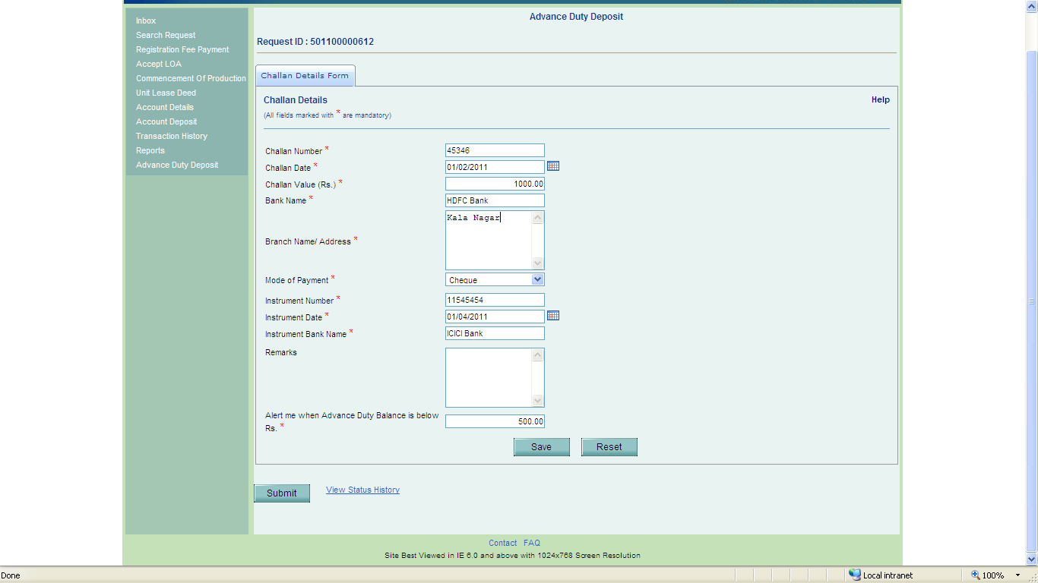
Fig: Screen of ‘Advance Duty Deposit’ form
- Confirmation Screen:
After preparation of the Advance duty deposit request, as the unit approver user clicks on SUBMIT button, a confirmation screen is displayed to the user wherein the contents of the Advance duty deposit Request are displayed. The user may either confirm or cancel the submission of Request using the buttons provided in this page.
- General Instructions
- After entering details of Challan tab, SAVE button has to be clicked to save the information entered.
- The fields marked with a red asterix mark “*” are mandatory. The Advance duty deposit request cannot be submitted without entering information in the mandatory fields.
- A unique request id will be generated by the system as the Unit Approver user clicks on the SAVE button for the first time. The Request can be tracked in future by using this no.
- The unit will not be able to make any changes in the Request after submitting it to customs.
- At any given point of time, only one user can work on the request. The user in whose inbox the Advance duty deposit Request is laying can only take action.

Approval of Advance Duty Deposit Request by Customs:
As Unit Approver submits the request electronically, it moves to the ‘Inbox’ of Authorized Officer, who will be able to view and process it. The authorized Officer will process the request only on receipt of the TR-6 challan counterfoil issued by the bank. After verification of the Challan details specified in the Advance Duty Deposit Request the challan counter foil presented by the unit,
- If the Authorized Officer finds everything to be in order, the Request will be approved. On Approval, the amount of the Advance duty deposited (Challan Amount) will get credited in the Advance Duty Ledger of the SEZ Unit in SEZ Online System.
- If the Authorized Officer finds the challan details to be incorrect, he may either reject the request & update the status as ‘Rejected’ or modify the contents of the request & approve.

Search Advance Duty Deposit Request
The unit users can search for any Advance duty deposit Request that they have prepared/submitted to Customs Office by using the search facility provided in the SEZ Online system. The users can track the status of their Request by using this facility. Advance duty deposit Request can be searched on the basis of the following parameters
- Date of submission of the Request to Customs
- Request ID
- Status of the Request

Advance Duty Ledger Report:
The Unit Approver user may view Advance Duty Ledger Report through the link: ReportAdvance Duty Ledger Report
Details of all the Advance Duty Deposits made by the unit & the DTA Sale transactions where the Advance Duty amounts have been utilized are reflected in this report.
- The Advance Duty Deposit Amount will be credited in the ledger only after approval from Authorized officer.
- If the Authorized Officer rejects the “Advance Duty Deposit” request, the same will not be reflected in the ledger.
- On submission of the DTA Sales transaction where the unit has selected the option of ‘Advance Duty Paid’, the duty amount of the transaction will be blocked in his Advance Duty Ledger. The blocked amount will not be available for utilization in new DTA Sale Transactions. The blocked amount will be debited from the Advance Duty Ledger balance as the Customs Assessor assesses the DTA Sale request & duty is payable.
- Advance Duty ledger balance will be calculated as follows:
Total Balance = Sum of all CREDIT entries minus Sum of all DEBIT entries
Available balance = Total Balance minus Blocked amount
Note: While submission of DTA Sales transaction, where the unit has selected the option of ‘Advance Duty Paid’, system will allow submission only if ‘Available Balance’ in Advance duty ledger is greater than the Duty payable for that particular transaction.
    - In a scenario where the unit has submitted a DTA Sales with “Advance Duty Paid” ticked & the customs assessor has assessed & thus, duty has been debited from the Advance Duty Ledger Account of the unit. The request has now moved to the authorized officer for issuance of out of charge. However, now if the authorized officer marks discrepancy and subsequently, the customs assessor raises a query & the unit now makes changes in the request such that the duty amount changes, in that case, a new debit /credit entry will be passed in the Advance Duty Ledger with the same request id & “Discrepancy” remark will be reflected in the “Remarks’ column.
    - Facility is provided to the unit user to export the advance duty ledger report into excel or print the same.
    - Unit user can search on the basis of request submission date range. By default, entries of the past one month will be displayed in the advance duty ledger.
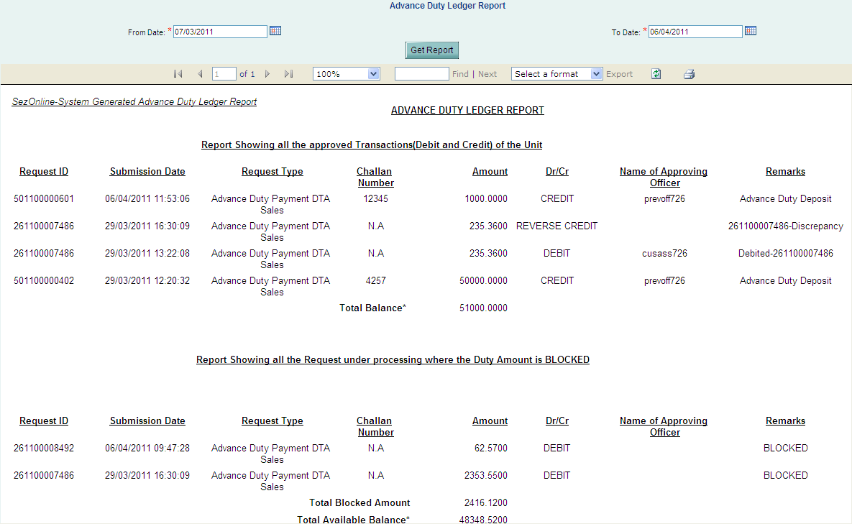
Fig: Advance Duty Ledger Report

Utilization of Advance Duty Ledger balance for paying duty in DTA Sale Transaction:
At the time of submission of DTA Sale transaction with Advance duty, Unit Maker as well as Unit Approver user should select a check box of Advance Duty Paid & submit the request. The same will be displayed in the Inbox of the Customs Officials. [For preparation & submission of DTA Sales transaction processes kindly refer to the Manual & demo available on website (www.sezonline-ndml.com).
If the Unit submits the request with tick mark in field ‘Advance Duty Paid’, it moves to ‘Customs Assessor’ for assessment. On Assessment, the request directly moves to Authorized Officer for ’Out of charge’. In this case the request will not go to the Unit User for entering challan details.
If the Custom Assessor selects to assess the document & issue Out of Charge a one step, he can do so. In this case, the request will not go to the Authorized Officer for Out of Charge & the request will get closed.

Various status of Advance Duty Deposit Request
Sr. No | Status | Description | Action to be taken by | Action options available to the Unit User
1 | Created | Advance duty deposit Request has been created by Unit Approver User but hasn’t been submitted to Authorized Officer | Unit Approver | Submit to Authorized Officer
5 | Submitted | Advance duty deposit has been submitted by Unit Approver to Authorized Officer. But, the Authorized Officer has not yet started processing it. | Authorized Officer | No action has to be taken by the unit users, as the Advance duty deposit Request is under process at DC Office.
6 | Approved | Advance duty deposit request approved by authorized officer. |  | No action has to be taken by the unit as the Advance duty deposit request is closed

Complete Workflow of DTA SALE ADP Request.

Submitted: When the DTA Sale request is submitted with the “Advance duty paid” checked from Unit Approver with status Submitted, the request moves to Customs Assessor. The unit approver has to submit the Advance duty payment request by signing it digitally.

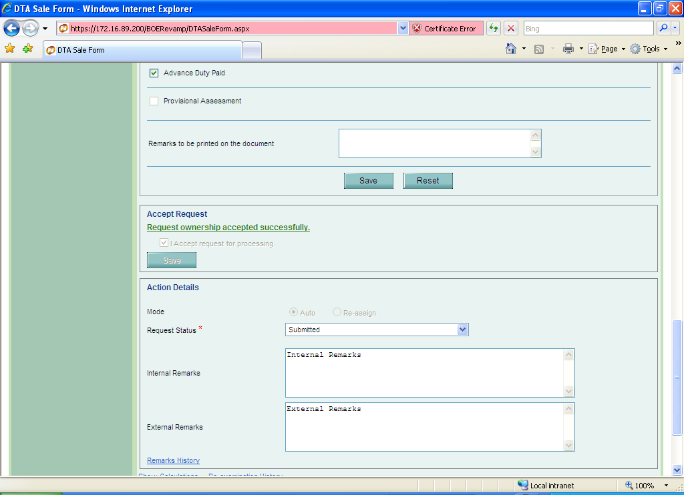
Fig: Screen available to entity user

  - The Custom Assessor has below statuses:
- Approved and Out of Charge with Advance Duty
- Approved with Duty
- Approved with Duty Forgone
- Cancellation Requested by Unit
- First Check Request
- Misuse Incident
- Raise Query
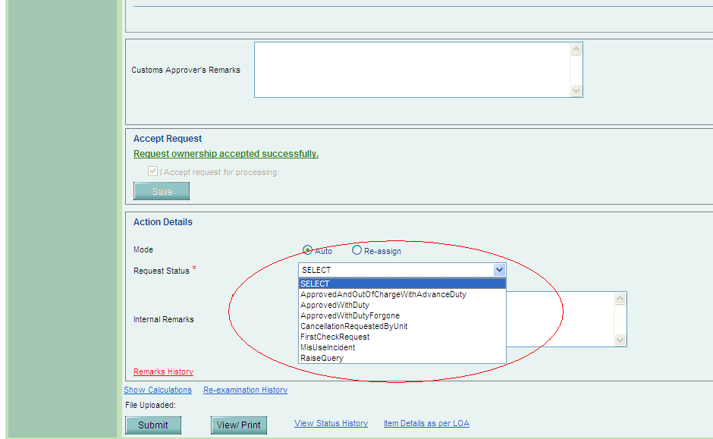
Fig: Drop down options available to Custom Assessor

- The Customs Assessor has two options. He can select “Approved with duty” or “Approved and out of Charge with Advance Duty”. Once he approves it the debit entry is made in the Ledger.
- Approve with Duty : If the unit submits the request with Advance duty Paid tick mark & the ‘Customs assessor’ selects the status as “Approve with Duty”, the request should directly move to Authorized officer for ’Out of charge’ i.e. It should not go to the unit for entering challan details.
- Approved and out of Charge with Advance Duty: If Customs Assessor selects “Approved and out of Charge with Advance Duty” then the request gets closed and the amount debited form the Unit’s Advance Duty deposit and is reflected in the Ledger.
The Customs Assessor has to approve the advance duty payment request by signing it digitally.
- First Check Request: If the customs assessor selects “First Check Request”/ re-examination, the request comes back to him from the Authorized officer either marked as “Discrepancy” or “First Check Completed”, The Authorized Officer has to approve the advance duty payment request by signing it digitally.
The customs assessor will have the following options:
    - Raise Query
    - Misuse Incident
    - Re-examination
    - Approved and out of Charge-Advance Duty (In this case the request will get closed).
    - Approved and Out of Charge without Duty
    - Approved with Duty
    - Approved without Duty

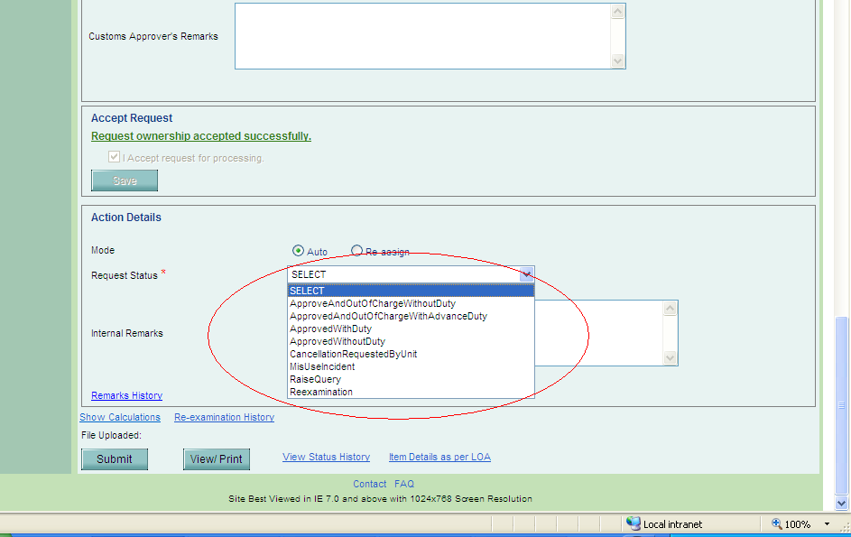
Fig: Drop down options available to Custom Assessor in first check request

- Cancellation Requested by Unit: In the DTA Sale transaction, if the request is cancelled by the Customs Assessor, the Debit entry in the ledger should be retained and a reverse credit entry of the same amount should be made with remarks as “Request Id-Cancelled”. (Ex: 261000000015-Cancelled)
- Amendment: On amendment of the DTA Sale request a reverse credit entry should be made of the original amount and then a debit entry should be made including the differential amount and “Remarks” column should reflect “Request Id-Amended”.
Export to Excel - A link will be provided to export the Ledger details to excel sheet.
8.1. Alerts & Notifications:
Alert should be sent to unit if the Advance Duty Deposit Ledger Balance goes below the minimum amount mentioned by the unit in ‘Advance Duty Deposit Screen’. The alert should be sent to all the Unit Approvers of the Unit.

